What is an OS? (Operating System — Deep & Practical Explanation)
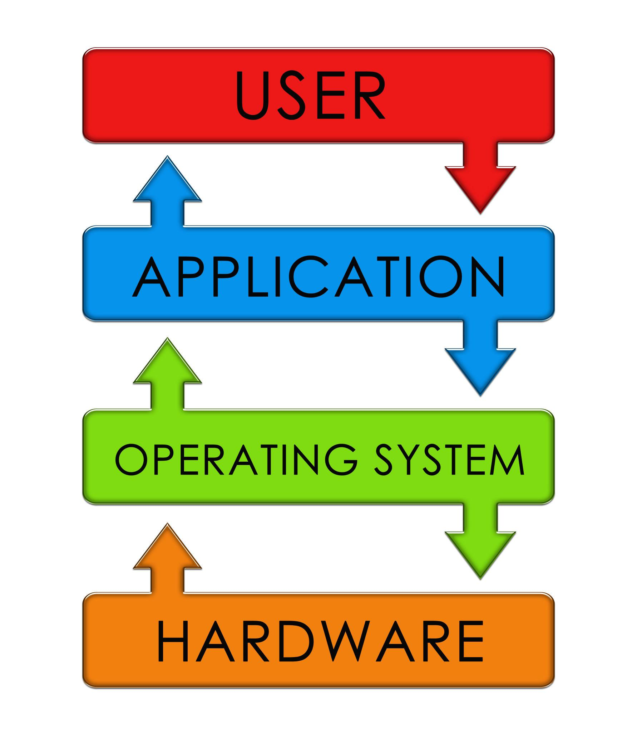
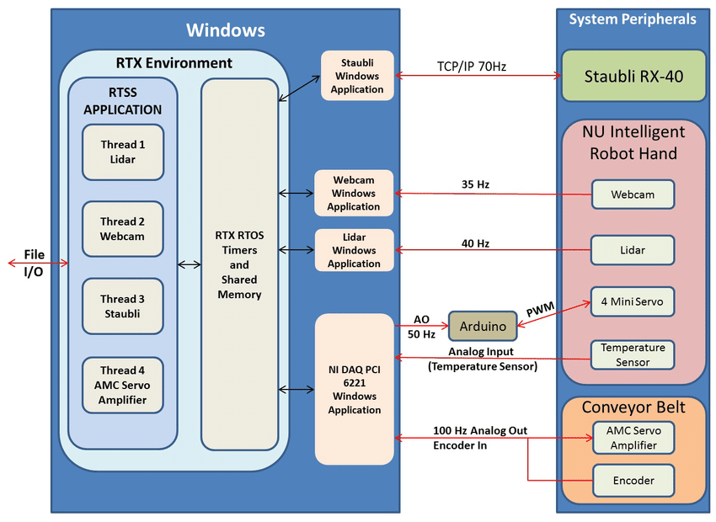
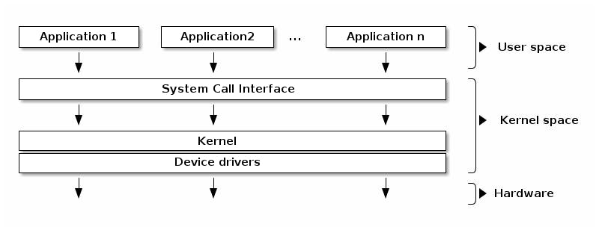
OS = Operating System
The OS is the core software layer that makes a computer usable.
It does three fundamental jobs:
- ⚙️ Controls hardware
  - CPU scheduling
  - RAM allocation
  - Storage access
  - GPU & device control
- 📱 Runs applications
  - Loads apps into memory
  - Shares CPU time
  - Prevents one app from crashing others
- 🔗 Interface between user & machine
  - GUI (windows, icons, mouse)
  - CLI (terminal, shell)
Without an OS, hardware is just powered metal.

🧩 What an OS Manages (Internals)

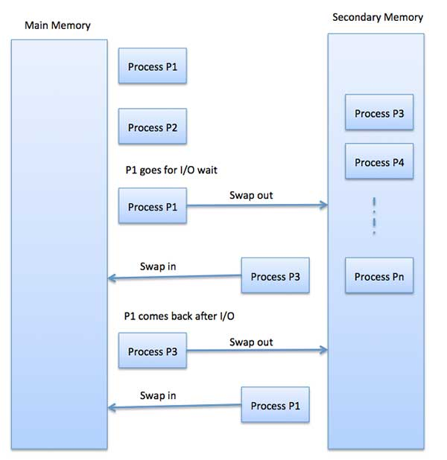
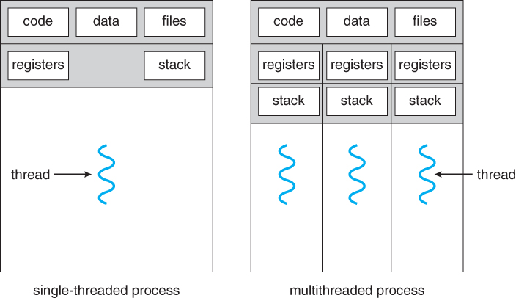
Key responsibilities:
- Process management → which program runs when
- Memory management → how RAM is shared
- File system → how data is stored & retrieved
- Device management → keyboard, mouse, GPU, USB
- Security → user permissions, isolation

🖥️ Common Operating Systems
- Microsoft Windows → general users, gaming
- Linux → servers, development, research
- macOS → Apple hardware (closed ecosystem)
(We’ll stay hardware-focused here.)

🔄 OS Installation Flow (Real System Boot Chain)
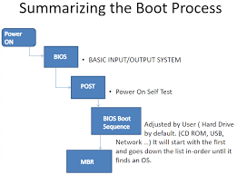
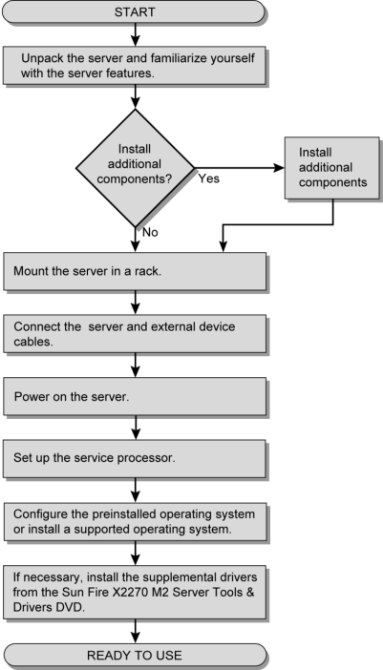
The real flow:
Power ON
↓
BIOS / UEFI
↓
Bootloader
↓
OS Installation
↓
Drivers
↓
Fully usable system
Each step is mandatory.

1️⃣ BIOS / UEFI (First Thing That Runs)
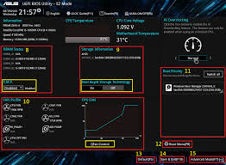
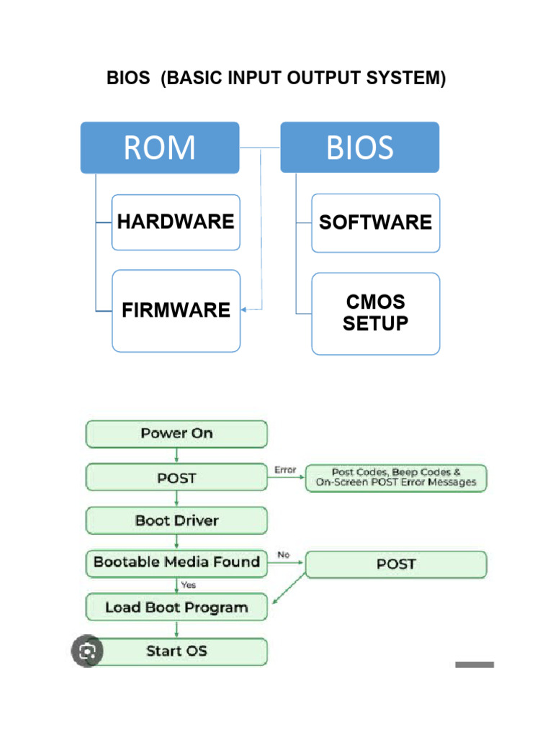
⚙️ What BIOS does:
- Initializes CPU, RAM, GPU, storage
- Checks hardware presence (POST)
- Decides boot device order
- Hands control to OS bootloader
📌 BIOS = hardware wake-up system
Modern systems use UEFI, but role is same.

2️⃣ Boot Process

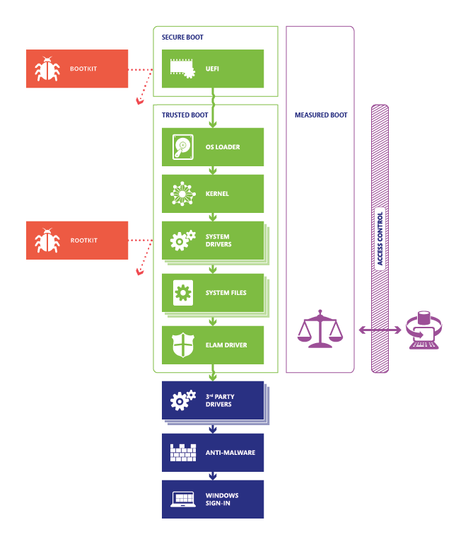
Bootloader:
- Small program on storage
- Loads OS kernel into RAM
Examples:
- Windows Boot Manager
- GRUB (Linux)
If bootloader fails → OS never loads

3️⃣ OS Installation
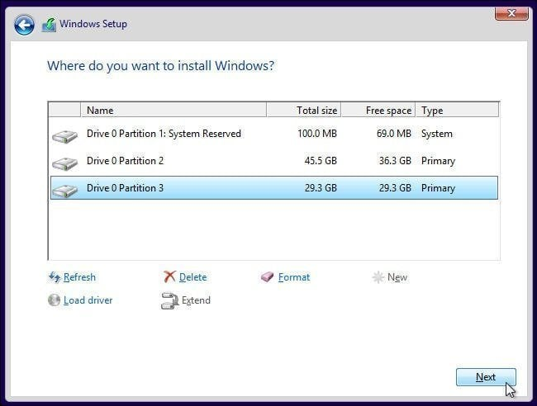
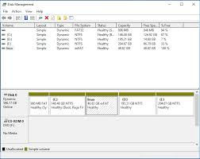
During installation:
- Disk is partitioned
- File system is created
- Kernel + system files copied
- Bootloader installed
At this stage:
❌ Hardware runs in basic mode
❌ Performance is NOT optimized

4️⃣ Drivers (CRITICAL STEP)
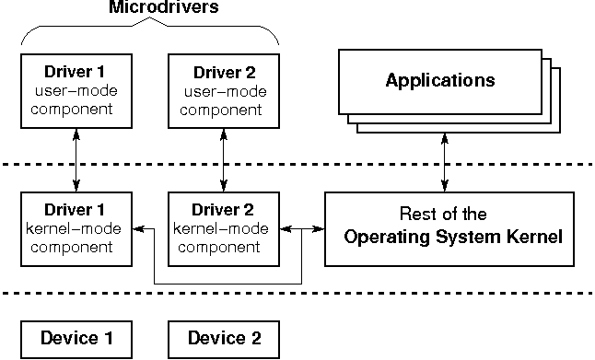
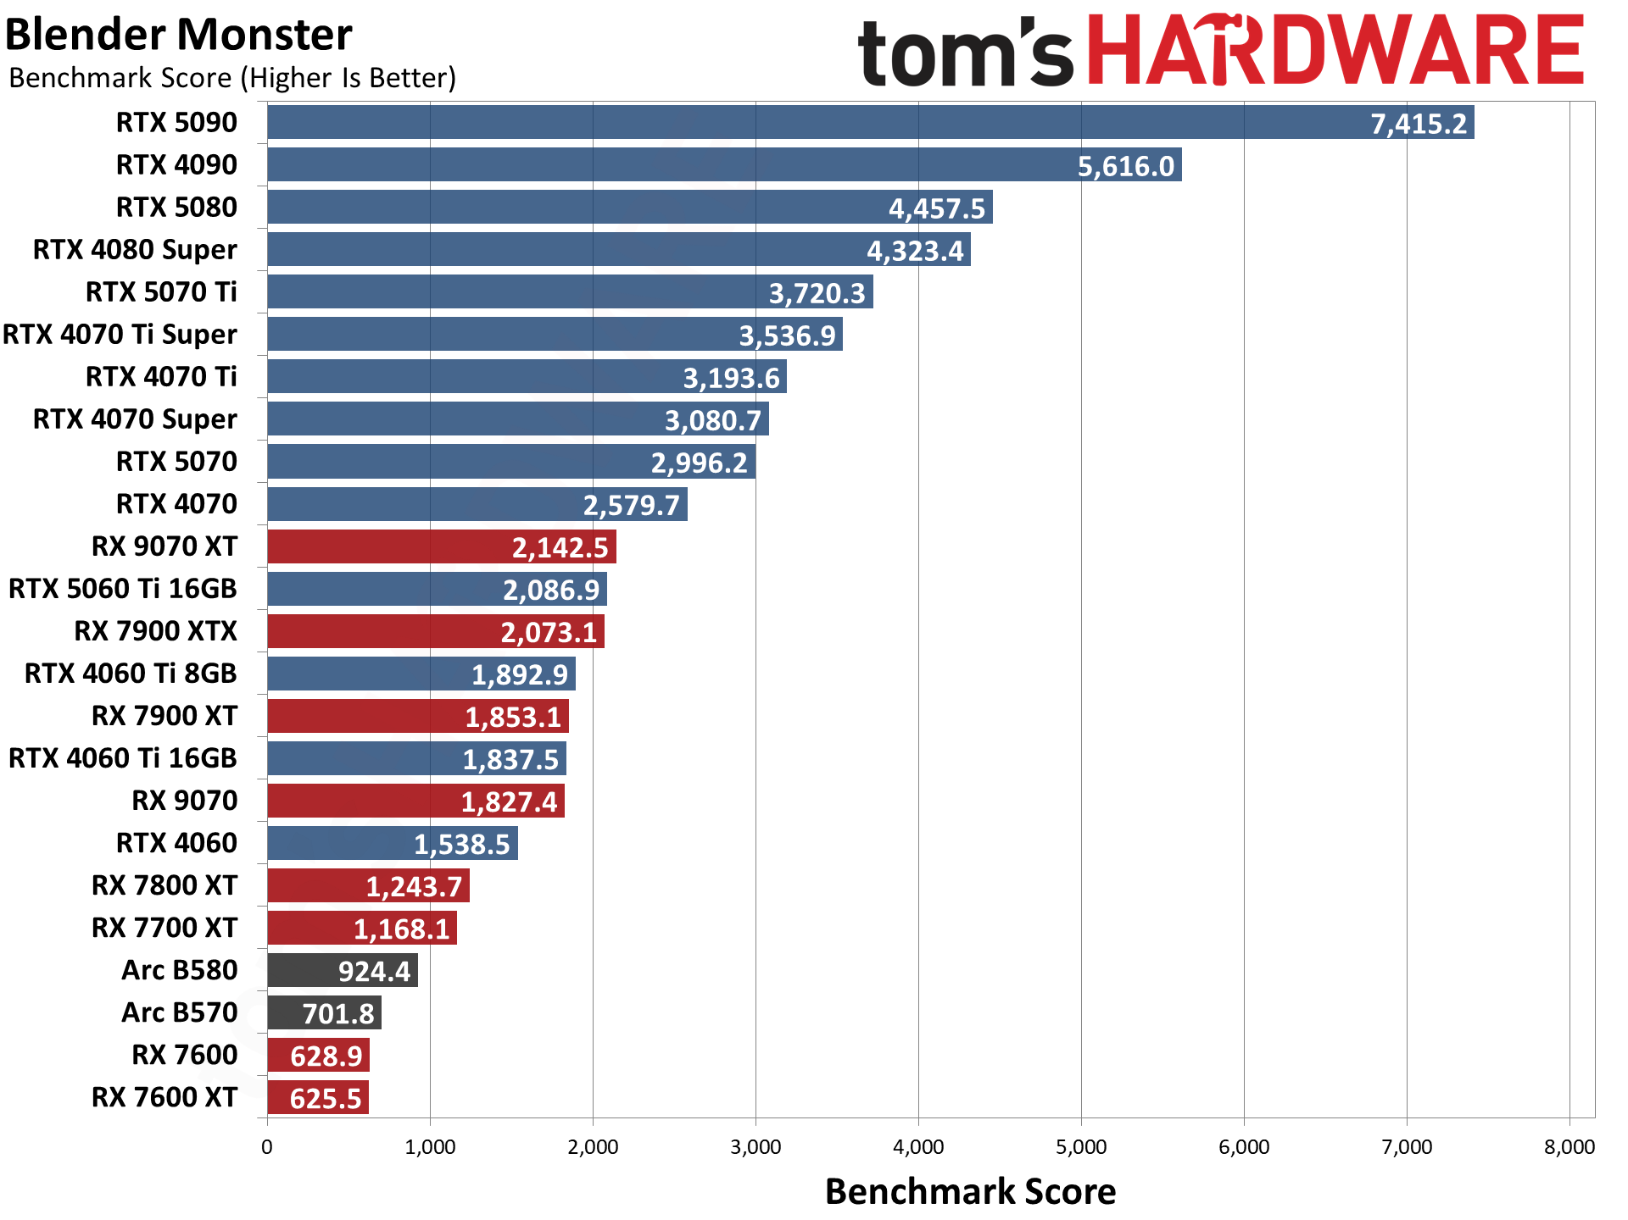
🚀 What are drivers?
Drivers are translators between OS and hardware.
Without drivers:
- GPU runs in basic mode
- CPU features unused
- SSD not at full speed
- Wi-Fi unstable
📌 Skipping drivers = wasting hardware money

⚙️ BIOS & Drivers (Performance Unlockers)

⚙️ BIOS Responsibilities (Advanced)
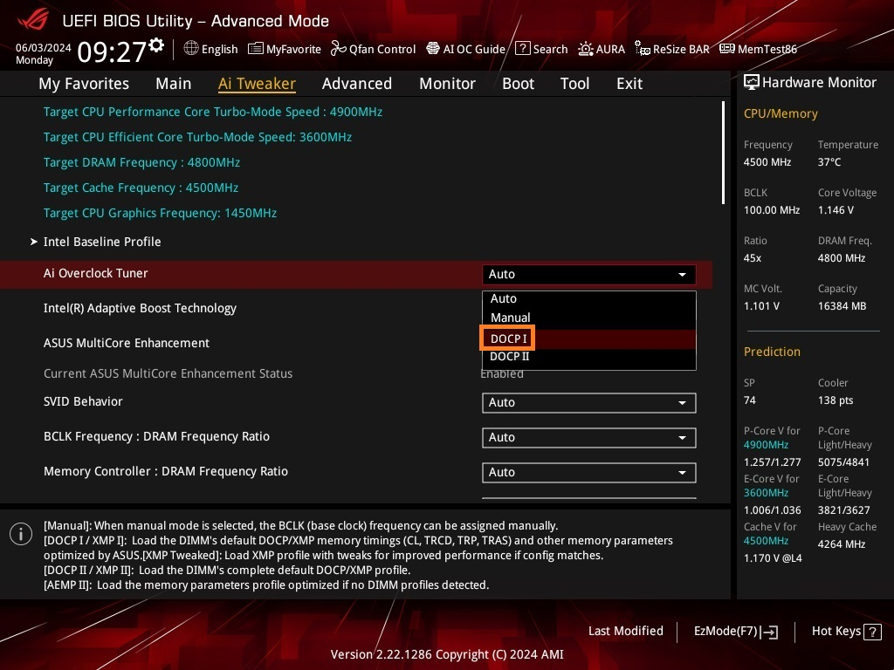
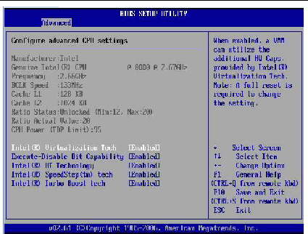
BIOS controls:
- RAM frequency
- CPU boost behavior
- Power limits
- Fan curves
- Boot mode (UEFI/Legacy)

⚡ XMP / EXPO (VERY IMPORTANT)
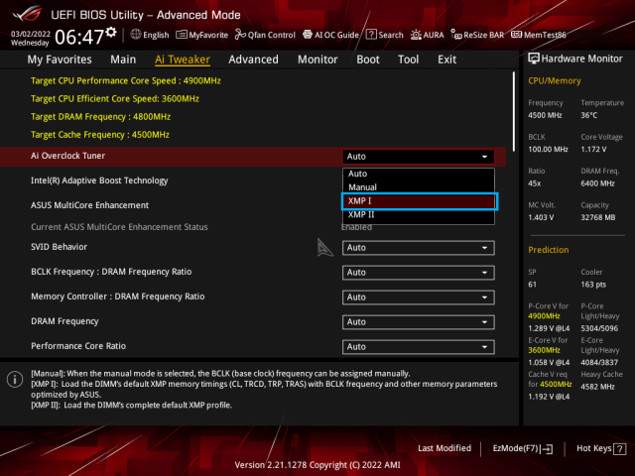

Problem:
Your RAM might be rated at 3200 MHz
But BIOS runs it at 2133 MHz by default
Solution:
- XMP → Intel
- EXPO → AMD
Enabling this:
- Instantly boosts RAM speed
- Improves system responsiveness
- Helps integrated GPU & AI workloads
⚠️ Not enabling XMP/EXPO = lost performance

🧠 OS + Drivers = Real Performance
Component | Without Driver | With Driver
GPU | Low resolution | Full power
CPU | No boost | Turbo enabled
SSD | Slow | NVMe speeds
LAN/Wi-Fi | Unstable | Full speed

🧩 Additional Important OS Concepts (Must Know)

1️⃣ Kernel (Heart of OS)

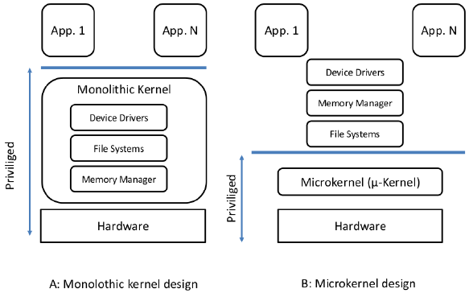
- Core part of OS
- Handles CPU, memory, I/O
- Runs with highest privilege
Crash in kernel → system crash

2️⃣ 32-bit vs 64-bit OS
OS Type | RAM Limit
32-bit | ~4 GB
64-bit | 128GB+
📌 Modern systems must use 64-bit OS

3️⃣ File Systems
OS | File System
Windows | NTFS
Linux | ext4, xfs
File system affects:
- Reliability
- Performance
- Recovery

4️⃣ OS Updates
- Security patches
- Driver compatibility
- Performance improvements
Skipping updates:
- Bugs
- Instability
- Security risks

5️⃣ OS & Hardware Scheduling
Modern OS:
- Schedules tasks across CPU cores
- Balances performance vs power
- Coordinates CPU ↔ GPU workloads
Especially important for:
- Intel P-core / E-core CPUs
- Multicore AMD systems

🧪 Real-World Example
Same PC, same hardware:
State | Result
Fresh OS, no drivers | Laggy
Drivers installed | Smooth
XMP disabled | Slower
XMP enabled | Faster
Hardware unchanged
Only OS configuration changed

🎯 Best Practice OS Setup (Checklist)
✅ Update BIOS (if stable)
✅ Install OS on NVMe SSD
✅ Install chipset drivers first
✅ Install GPU drivers
✅ Enable XMP / EXPO
✅ Update OS

🏁 Final Core Truths
- OS is the brain software
- BIOS wakes hardware
- Drivers unlock hardware
- RAM speed needs manual enabling
- Bad OS setup = wasted hardware

🧠 One-Line Summary
Hardware gives potential.
OS + BIOS + drivers decide how much of it you actually use.

